**ONLINE VOTING SYSTEM**

**A PROJECT REPORT**

**For**

**Major Project (KCA451)**

**Session (2023-24)**

**Submitted by**

**Sheetal Gupta**

**(2200290140142)**

**Submitted in partial fulfilment of the**

**Requirements for the Degree of**

**MASTER OF COMPUTER APPLICATIONS**

**Under the Supervision of**

**Dr. Shashank Bhardwaj**

### Associate Professor



**Submitted to**

**Department Of Computer Applications**

**KIET Group of Institutions, Ghaziabad**

**Uttar Pradesh-201206**

**(MARCH 2024)**

**DECLARATION**

I hereby declare that the work presented in report entitled “Online Voting System” was carried out by me. I have not submitted the matter embodied in this report for the award of any other degree or diploma of any other University of Institute. I have given due credit to the original authors/sources for all the words, ideas, diagrams, graphics, computer programs, that are not my original contribution. I have used quotation marks to identify verbatim sentences and give credit to the original authors/sources. I affirm that no portion of my work is plagiarized, and the experiments and results reported in the report are not manipulated. In the event of a complaint of plagiarism and the manipulation of the experiments and results, I shall be fully responsible and answerable.

**Name:** Sheetal Gupta **Roll No.:** 2200290140142

**Sheetal Gupta**

**CERTIFICATE**

Certified that **Sheetal Gupta 2200290140142** has carried out the project work having “**Online Voting System**” (**Major Project-KCA353**) for **Master of Computer Application** from Dr. A.P.J. Abdul Kalam Technical University (AKTU**)** (formerly UPTU), Lucknow under my supervision. The project report embodies original work, and studies are carried out by the student herself and the contents of the project report do not form the basis for the award of any other degree to the candidate or to anybody else from this or any other University/Institution.

**Date: Sheetal Gupta (2200290140142)**

This is to certify that the above statement made by the candidate is correct to the best of my knowledge.

Date:

**Dr. Shashank Bhardwaj Dr. Arun Tripathi**

**Associate Professor Head**

**Department of Computer Applications Department of Computer Applications**

**KIET Group of Institutions, Ghaziabad KIET Group of Institutions, Ghaziabad**

**ABSTRACT**

We are developing an on-line voting system by taking advantage of centralized database with a web interface. The main concept of this project is to build a website, which will be able to allow people to cast their vote through on-line. Time saving, working load reduced, information available at time and it provides security for data

In a democratic country like India we are not getting 100% of voting. People are not ready to poll their vote because of many factors like people can’t go to the polling stations to cast their vote (especially aged persons and physically challenged people). People may be at remote places.

There are several issues with traditional paper based voting like ridging votes during election, insecure or inaccessible polling station. Inadequate polling materials and also inexperienced personnel. This On-line Voting System seeks to address the above issues. With this system The citizens may get ample time during the voting period

Efficient data storage is achieved through the utilization of a relational database, ensuring that student records and results are stored in a structured and organized manner, facilitating easy retrieval and manipulation as needed.

Every citizen is registered first and all the details are managed at centralized database. And at the time of elections the citizens will be login through their credentials and cast their vote

**ACKNOWLEDGEMENTS**

Success in life is never attained single-handedly. My deepest gratitude goes to my project supervisor, **Dr. Shashank Bhardwaj** for his guidance, help, and encouragement throughout my project work. Their enlightening ideas, comments, and suggestions.

Words are not enough to express my gratitude to **Dr. Arun Kumar Tripathi**, Professor and Head, Department of Computer Applications, for his insightful comments and administrative help on various occasions.

Fortunately, I have many understanding friends, who have helped me a lot on many critical conditions.

Finally, my sincere thanks go to my family members and all those who have directly and indirectly provided me with moral support and other kind of help. Without their support, completion of this work would not have been possible in time. They keep my life filled with enjoyment and happiness.

**TABLE OF CONTENTS**

Name of ContentPage no.

1. Declaration……………………………………………………………………...2

B). Certificate…………………………………………………………………..........3

C). Abstract………………………………………………………………………….4

D). Acknowledgement……………………………………………………………….5

E). Table of Content………………………………………………………………….6 - 8

F). List of Abbreviation………………………………………………………………9

G). List of Table……………………………………………………………………./.10

1. Introduction**………………………………………………………………….…………..**10-11

1.1 - Overview……………………………………………………………………/…..10

1.2 - Project Description…………………………………………………….……… ..10

1.2.1 Project Scope……………………………………………………..…………..10

1.2.2 Target Audience………………………………………………….…………...10

1.3 - Hardware / Software……………………………………………………………...10

1.3.1 Hardware Requirement………………………………………………………..10

1.3.2 Software Requirement………………………………………………………….11

2. Feasibility Study**…………………………………………………………….….....................**12-13

2.1 - Technical Feasibility………………………………………………………….…12

2.2 - Operational Feasibility…………………………………………………………..13

2.3 - Behavioural Feasibility…………………………………………………………..13

3. Design**…………………………………………………………………….………… …**14-23

3.1 Use Case Diagram…………………………………………………....…………..14-16

3.2 Er Diagram…………………………………………………………………………….17

3.1 Database Design………………………………………………………… …….18-23

3.1.1 Admin Table……………………………………………………….........18

3.1.2 Sign up Table……………………………………………………............18

3.1.3 Candidate Table…………………………………………………………19

3.1.4 Voter Table………………………………………………………………19

3.2 - Flow Chart Diagrams……………………………………………….… ……20

3.3 - Data Flow Diagrams…………………………………………………………21-23

4 Project Planning and Scheduling ………………………………………………………………………………….............24-30

4.1 Introduction …………………………………………………./…………………24

4.2 Components of the project……………………………………………………….25-27

4.3 The 5 phases of a project…………………………………………………………28

4.4 Pert Chart………………………………………………………………………29-30

5 Project Screenshots**……………………………………………………….……………..**31-35

5.1 - Login Page……………………………………………………………… ,…….31

5.2 – Signup Page……………………………………………………………………32

5.3 - Dashboard……………………………………………………………………...33

5.4 – Add Candidate…………………………………………………………………34

5.5-Advoter……………………………………………………………………........35

6. Choice of Tools & Technology ………………………………………………………………………………………….36-39

6.1 PHP ………………………………………………………………………………36

6.2 MySQL ……………………………………………………………………………37

6.3 Data Flow Diagram ……………………………………………………………….38

6.4 Context Level Diagram……………………………………………………………39

7. Testing**…………………………………………………………………………….**40-41

7.1 Testing Case………………………………………………………………………40

7.2 Test Case………………………………………………………………………....40

7.2.1 Login Case ………………………………………………………………..41

7.2.2 Sign up Case…………………………………………………………………....41

6. Future Scope**………………………………………………………………………**42-44

6.1 Conclusion……………………………………………………………………43

7. Bibliography………………………………………………………………………44

**LIST OF ABBREVIATIONS**

**Sr.no Abbreviation Definition**

1 HTML Hyper Text Mark-up Language

2 CSS Cascading Style Sheets

3 PHP Hypertext Pre - Pprocessor

4 DFD Data Flow Diagram

5 XAMPP Cross Platform Apache My SQL PHP Perl

6 MYSQL My Structured Query Language

**LIST OF TABLES**

**Sr.no Name of Table Page Number**

1 ADMIN 16

2 SIGN UP 17

3 CANDIDATE 18

4 VOTER 18

**CHAPTER 1**

**INTRODUCTION**

* 1. **OVERVIEW**

The Online Voting System, is a comprehensive endeavour to replicate the functionality and user experience of the renowned microblogging platform. Motivated by the desire to understand and implement key features of a modern Result Management System, this project encompasses a range of technical aspects spanning front-end development, back-end infrastructure, and real- time communication.

* 1. **PROJECT DESCRIPTION**

The Secure Online Voting System is a web-based platform designed to facilitate secure, efficient, and convenient voting processes for various types of elections, including governmental, organizational, or institutional elections.

**1.2.1 Project Scope:**

This will encompass the core functionalities of Voting Management System, including

**User registration and profiles:** Create accounts, edit profiles, and manage users.

**Interactions:** add, remove, and update the records.

* + 1. **Target Audience:**

This Platform targets individuals and communities seeking a dynamic platform for:

* **Sharing quick updates.**
* **Connecting with the Collaborators.**
* **Engaging in quality-based Record System.**

**1.3 HARDWARE REQUIREMENTS**

* Hardware: Processor i3 or above
* Clock speed**:** 3.0 GHz
* RAM size**:** 4 GB or above
* Hard Disk capacity**:** 500 GB or above

* 1. **SOFTWARE REQUIREMENTS**
* Operating System**:** Windows 10
* Browser**:** Google chrome or any other
* Application software**:** Visual Studio Code
* Technology**:** PHP
* Server Required**:** XAMPP
* Language Required**:** HTML, CSS, JAVASCRIPT
* Documentation**:** MS Word

**CHAPTER 2**

**FEASIBILITY STUDY**

A feasibility study analyses the viability of a project to determine whether the project or venture is likely to succeed. The study is also designed to identify potential issues and problems that could arise while pursuing the project.

A feasibility study evaluates a project's or system's practicality. As part of a feasibility study, the objective and rational analysis of a potential business or venture is conducted to determine its strengths and weaknesses, potential opportunities and threats, resources required to carry out, and ultimate success prospects. Two criteria should be considered when judging feasibility: the required cost and expected value. A feasibility study is a comprehensive evaluation of a proposed project that evaluates all factors critical to its success in order to assess its likelihood of success. Business success can be defined primarily in terms of ROI, which is the amount of profits that will be generated by the project.

**2.1 TECHNICAL FEASIBILITY**

Technical feasibility study is concerned with specifying equipment and software that will successfully satisfy the user requirement; the technical needs of the system may vary considerably. The facility to produce outputs in a given time. A technical feasibility study reviews the technical resources available for your project. This study determines if you have the right equipment, enough equipment, and the right technical knowledge to complete your project objectives.

For example, if your project plan proposes creating 50,000 products per month, but you can only produce 30,000 products per month in your factories, this project isn’t technically feasible. This assessment focuses on the technical resources available.

To the organization. It helps organizations determine whether the technical resources meet capacity and whether the technical team is capable of converting the ideas into working systems. Technical feasibility also involves the evaluation of the hardware,

Software, and other technical requirements of the proposed system. As an exaggerated example, an organization wouldn’t want to try to put Star Trek’s transporters in their building—currently, this project is not technically feasible.

**2.2 BEHAVIOURAL FEASIBILITY**

Behavioural feasibility is a critical aspect to consider when developing a Twitter clone project. This feasibility study assesses whether users and stakeholders are likely to accept and adapt to the new microblogging platform based on their behavioural patterns, preferences, and expectations. The literature on behavioural feasibility for social media platforms, including microblogging services, can provide valuable insights into user behaviour and acceptance. Behavioural feasibility for a Twitter clone project involves a comprehensive analysis of user behaviour, preferences, and cultural considerations.

Drawing upon existing literature on user behaviour in social media, UX design, feature acceptance, community building, adoption patterns, and user feedback can provide a solid foundation for developing a microblogging platform that aligns with user expectations and encourages widespread adoption.

**2.3 OPERATIONAL FEASIBILTY**

Operation feasibility is used to check whether the project is operationally feasible or not. Our project is mainly different from the other system because of its web-support feature. So the measure for operational feasibility is something different from other system.

Generally, the operational feasibility is related to organization aspects. The change determination is as such that early product were either a man or group of men or the jobs

Based manual but now a day with the advent of Internet technology. This assessment involves undertaking a study to analyse and determine whether—and how well—the organization’s needs can be met by completing the project .Operational feasibility studies also examine how a project plan satisfies the requirements identified in the requirements analysis phase of system development. This assessment typically involves a cost/ benefits analysis of the project, helping organizations determine the viability, cost, and benefits associated with a project before financial resources are allocated.

**CHAPTER 3**

**DESIGN**

Software design sits at the technical kernel of the software engineering process and is applied regardless of the development paradigm and area of application. Design is the first step in the development phase for any engineered product or system. The designer’s goal is to produce a model or representation of an entity that will later be built. Beginning, once system requirement have been specified and analysed, system design is the first of the three technical activities - design, code and test that is required to build and verify software. The importance can be stated with a single word “Quality”.

Design is the place where quality is fostered in software development. Design provides us with representations of software that can assess for quality. Design is the only way that we can accurately translate a customer’s view into a finished software product or system. Software design serves as a foundation for all the software engineering steps that follow. Without a strong design we risk building an unstable system – one that will be difficult to test, one whose quality cannot be assessed until the last stage.

During design, progressive refinement of data structure, program structure, and procedural details are developed reviewed and documented. System design can be viewed from either technical or project management perspective. From the technical point of view, design is comprised of four activities – architectural design, data structure design, interface design and procedural design. System Design is the process of designing the architecture, components, and interfaces for a system so that it meets the end-user requirements.

System Design for tech interviews is something that can’t be ignored! Almost every IT giant whether it be Facebook, Amazon, Google, Apple or any other ask various questions based on System Design concepts such as scalability, load-balancing, caching, etc. in the interview. This specifically designed System Design tutorial will help you to learn and master System Design concepts in the most efficient way from basics to advanced level.

**3.1 USE CASE DIAGRAM**

In the Unified Modelling Language (UML), a use case diagram can summarize the details of your system's users (also known as actors) and their interactions with the system. To build one, you'll use a set of specialized symbols and connectors. A use case diagram doesn't go into a lot of detail—for example, don't expect it to model the order in which steps are performed. Instead, a proper use case diagram depicts a high-level overview of the relationship between use cases, actors, and systems. Experts recommend that use case diagrams be used to supplement a more descriptive textual use case.

UML is the modelling toolkit that you can use to build your diagrams. Use cases are represented with a labelled oval shape. Stick figures represent actors in the process, and the actor's participation in the system is modelled with a line between the actor and use case. To depict the system boundary, draw a box around the use case itself.

These diagrams are used at a very high level of design. This high level design is refined again and again to get a complete and practical picture of the system. A well-structured use case also describes the pre-condition, post condition, and exceptions. These extra elements are used to make test cases when performing the testing.

Although use case is not a good candidate for forward and reverse engineering, still they are used in a slightly different way to make forward and reverse engineering. The same is true for reverse engineering. Use case diagram is used differently to make it suitable for reverse engineering.

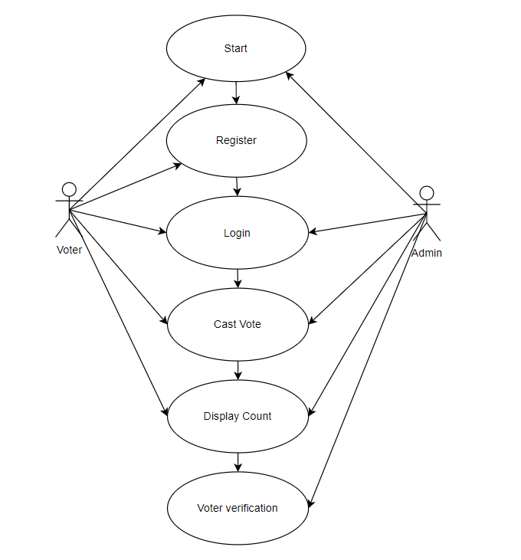

Figure 3.1: Use Case Diagram (3.1)

**3.2 ­ER - DIAGRAM**

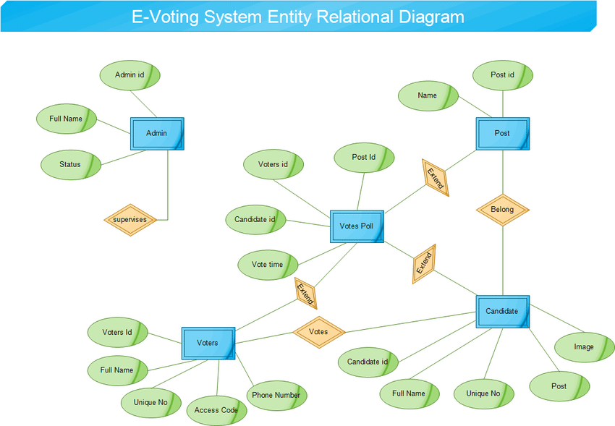

Figure 3.2 Er Diagram

**3.1 DATABASE TABLES**

**3.1.1 ADMIN TABLE**

|  |  |  |
| --- | --- | --- |
| **FIELD** | **TYPE** | **CONSTRAINTS** |
| Username | Varchar2(255) | - |
| Password | Varchar2(255) | - |

Table No 3.1 Admin

**3.1.2 SIGN UP PAGE**

|  |  |  |
| --- | --- | --- |
| **FIELD** | **TYPE** | **CONSTRAINTS** |
| Id | Int | PRIMARY KEY |
| Password | VARCHAR | NOT NULL |

Table no 3.2 Sign up page

**3.1.3 CANDIDATE TABLE**

|  |  |  |
| --- | --- | --- |
| **FIELD** | **TYPE** | **CONSTRAINTS** |
| ID | INT | PRIMARY KEY |
| POSITION | CHARATER | PRIMARY KEY |
| FIRST NAME | VARCHAR | PRIMARY KEY |
| LAST NAME | VARCHAR | PRIMARY KEY |
| GENDER | CHAR | PRIMARY KEY |
| IMAGE | - | PRIMARY KEY |

Table No 3.3 Candidate

**3.1.4 VOTER TABLE**

|  |  |  |
| --- | --- | --- |
| **FIELD** | **TYPE** | **CONSTRAINTS** |
| ID | Int(11) | PRIMARY KEY |
| PASSWORD | Varchar2(225) | DEFAULT NULL |
| FIRST NAME | VARCHAR2 | PRIMARY KEY |
| LAST NAME | NUMBER | PRIMARY KEY |
| GENDER | CHAR | PRIMARY KEY |

Table No 3.4 Voter

**3.2 FLOWCHART DIAGRAM**

Flowcharts are nothing but the graphical representation of the data or the algorithm for a better understanding of the code visually. It displays step-by-step solutions to a problem, algorithm, or process. It is a pictorial way of representing steps that are preferred by most beginner-level programmers to understand algorithms of computer science, thus it contributes to troubleshooting the issues in the algorithm.

A flowchart is a picture of boxes that indicates the process flow in a sequential manner. Since a flowchart is a pictorial representation of a process or algorithm, it’s easy to interpret and understand the process.

To draw a flowchart, certain rules need to be followed which are followed by all professionals to draw a flowchart and is widely accepted all over the countries.

**3.2.1 Process flowchart:**

This type of flowchart shows all the activities that are involved in making a product. It basically provides a pathway to analyse the product to be built. A process flowchart is most used in process engineering to illustrate the relation between the major as well as minor components present in the product. It is used in business product modelling to help understand employees about the project requirements and gain some insight about the project.

**3.2.2** **Data flowchart:**

As the name suggests, the data flowchart is used to analyse the data, specifically it helps in analysing the structural details related to the project. Using this flowchart, one can easily understand the data inflow and outflow from the system. It is most commonly used to manage data or to analyse information to and fro from the system.

**3.2.3 Business Process Modelling Diagram:**

Using this flowchart or diagram, one can analytically represent the business process and help simplify the concepts needed to understand business activities and the flow of information. This flowchart illustrates the business process and models graphically which paves a way for process improvement

**Flow Chart**

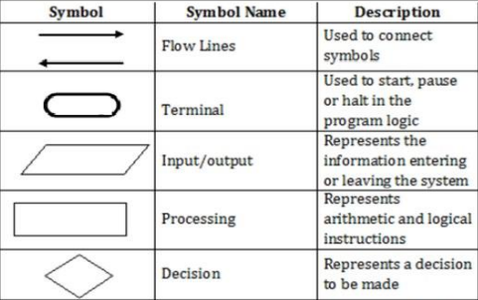

Figure: 3.2.1 Flow Chart

**3.3 DATA FLOW DIAGRAM**

**DFD** is the abbreviation for **Data Flow Diagram**. The flow of data of a system or a process is represented by DFD. It also gives insight into the inputs and outputs of each entity and the process itself. DFD does not have control flow and no loops or decision rules are present. Specific operations depending on the type of data can be explained by a flowchart. It is a graphical tool, useful for communicating with users, managers and other personnel. It is useful for analysing existing as well as proposed system.

It provides an overview of

* What data is system processes.
* What transformation are performed.
* What data are stored?
* What results are produced etc.?

Data Flow Diagram can be represented in several ways. The DFD belongs to structured- analysis Modelling tools. Data Flow diagrams are very popular because they help us to visualize the major steps and data involved in software-system processes.

The Data Flow Diagram has 4 components:

* Process Input to output transformation in a system takes place because of process function. The symbols of a process are rectangular with rounded corners, oval, rectangle or a circle. The process is named a short sentence, in one word or a phrase to express its essence
* Data Flow Data flow describes the information transferring between different parts of the systems. The arrow symbol is the symbol of data flow. A relatable name should be given to the flow to determine the information which is being moved. Data flow also represents material along with information that is being moved. Material shifts are modelled in systems that are not merely informative. A given

Flow should only transfer a single type of information. The direction of flow is represented by the arrow which can also be bi-directional.

* Warehouse The data is stored in the warehouse for later use. Two horizontal lines represent the symbol of the store. The warehouse is simply not restricted to being a data file rather it can be anything like a folder with documents, an optical disc, a filing cabinet. The data warehouse can be viewed independent of its implementation. When the data flow from the warehouse it is considered as data reading and when data flows to the warehouse it is called data entry or data updating.
* Terminator The Terminator is an external entity that stands outside of the system and communicates with the system. It can be, for example, organizations like banks, groups of people like customers or different departments of the same organization, which is not a part of the model system and is an external entity. Modelled systems also communicate with terminator.

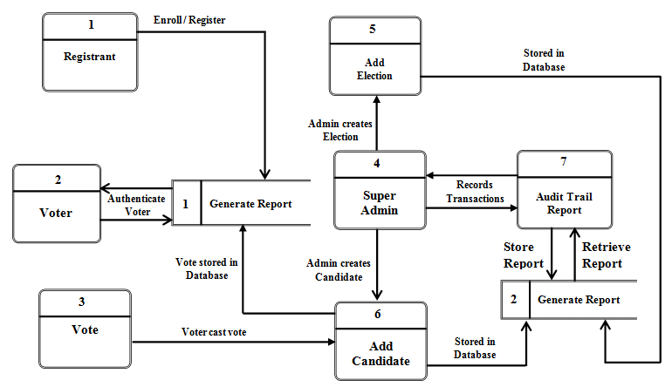

Figure 3.1 Data Flow Diagram

**CHAPTER 4**

**PROJECT PLANNING AND SCHEDULING**

**4.1 Introduction**

Project planning refers to the phase in project management in which you determine the actual steps to complete a project. This includes laying out timelines, establishing the budget, setting milestones, assessing risks, and solidifying tasks and assigning them to team members.

Project planning is a discipline addressing how to complete a project in a certain timeframe, usually with defined stages and designated resources.

One view of project planning divides the activity into these steps:

• Setting measurable objectives

• Identifying deliverables

• Scheduling

• Planning tasks

**A. Why is project planning important?**

Project planning is important at every phase of a project. It lays out the basics of a project, including the following:

• Scope

• Objectives

• Goals

• Schedule

* Planning enables project managers to turn an intangible idea into reality.

**B. Key purposes of planning include the following:**

• Facilitate communication and provide a central source of information for project personnel.

* Help the project sponsor and other key stakeholders know what is required;

• Identify who will perform certain tasks, and when and how those tasks will happen;

• Facilitate project management and control as the project progresses

• Enable effective monitoring and control of a project

• Manage project risk

• Generate feedback useful for the next project planning phase

**4.2 Components of a project plan**

The three major parts of a project plan are the scope, budget and timeline. They involve the following aspects: Scope: The scope determines what a project team will and will not do. It takes the team's vision, what stakeholders want and the customer's requirements and then determines what's possible. As part of defining the project scope, the project manager must set performance goals. Budget: Project managers look at what manpower and other resources will be required to meet the project goals to estimate the project's cost.

**How do you create a project plan?**

Project planning includes the following 10 steps:

1. **Define stakeholders**.

Stakeholders include anyone with an interest in the project. They can include the customer or end user, members of the project team, other people in the organization the project will affect and outside organizations or individuals with an interest.

1. **Define roles.**

Each stakeholder's role should be clearly defined. Some people will fill multiple roles.

1. **Introduce stakeholders.**

Hold a meeting to bring stakeholders together and unify the vision behind the project. The topics covered should include scope, goals, budget, schedule and roles.

1. **Set goals.**

Take what is gleaned from the meeting and refine it into a project plan. It should include goals and deliverables that define what the product or service will result in.

1. **Prioritize** **tasks.**

List tasks necessary to meet goals and prioritize them based on importance and interdependencies. A Gantt chart can be helpful for mapping project dependencies.

1. **Create a schedule**.

Establish a timeline that considers the resources needed for all the tasks.

1. **Assess risks:**

Identify project risks and develop strategies for mitigating them**.**

1. **Communicate.**

Share the plan with all stakeholders and provide communications updates in the format and frequency stakeholders expect.

.

**9. Final evaluation.** Once the project is completed, performance should be evaluated to learn the experience and identify areas to improve.

**Project Steps**

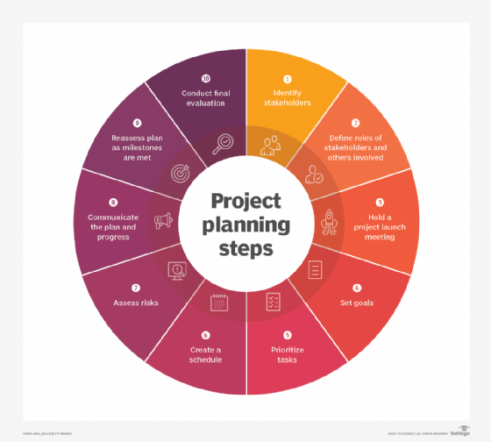

**Fig no : 4.2 Project Steps**

**Project Plan**

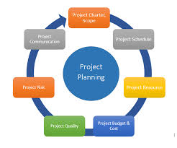

**Fig no: 4.2 Project Plan**

**4.3 The 5 phases of a project Projects typically pass through five phases**.

The project lifecycle includes the following:

• **Initiation:**

Defines project goals and objectives**.** It also is when feasibility is considered, along with how to measure project objectives.

**• Planning:**

Sets out the project scope. It establishes what tasks need to get done and who will do them.

**• Execution:**

Is when the deliverables are created. This is the longest phase of a project. During execution, the plan is set into motion and augmented, if necessary.

**• Monitoring:**

And management occur during the execution phase and may be considered part of the same step. This phase ensures that the project is going according to plan.

**• Closing:**

And review is the final Contracts are closed out and the final deliverables are given to the client. Successes and failures are evaluated.

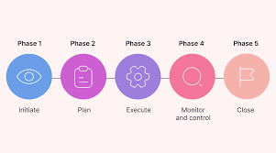

**Fig 4.3 Project lifecycle**

**4.4 Pert Chart:**

A PERT chart, short for Program Evaluation Review Technique, serves as a project management tool used to schedule, organize, and coordinate tasks within the Career Guidance Management System (CGMS) project. This chart presents a visual representation of the project as a network diagram consisting of numbered nodes, typically circles or rectangles, representing events or milestones in the project. These nodes are connected by labelled vectors, representing tasks in the project, with the direction of the arrows indicating the sequence of tasks.

In the context of the CGMS project, the PERT chart illustrates the interdependencies between various project tasks, such as system design, development, testing, deployment, and ongoing maintenance. By visualizing the project timeline and task dependencies, the PERT chart helps project managers and stakeholders effectively plan and manage project activities to ensure timely completion and successful implementation of the CGMS.

` The PERT chart is particularly useful in identifying the critical path of the project. The critical path is the longest sequence of tasks that must be completed on time for the entire project to be finished by its deadline. Identifying this path allows project managers to focus on tasks that directly impact the project timeline, ensuring that any delays in these critical tasks are promptly addressed to avoid impacting the overall project schedule

The creation of a PERT chart for the CGMS project involves several steps. The first step involves understanding the full scope of the CGMS project and clearly defining its objectives. This includes outlining the key features and functionalities of the system, such as user profiling, career path recommendations, machine learning model integration, and user interface design.

Next, break down the project into smaller, manageable tasks and identify key milestones. For the CGMS project, tasks might include requirements gathering, system architecture design, database setup, development of recommendation algorithms, user interface design, integration of AI and ML models, testing phases, and final deployment. 21 Then, identify the logical sequence of tasks and their dependencies.

Create the network diagram by placing the tasks in the appropriate sequence and connecting them with arrows to indicate dependencies. Number the nodes to represent milestones and label the vectors with task descriptions and estimated durations.

Analyse the PERT chart to identify the critical path, which is the longest path through the network diagram. This path determines the minimum project duration. Focus on monitoring and managing tasks on the critical path to ensure the project stays on schedule. As the project progresses, continuously monitor the status of tasks and update the PERT chart accordingly. If any tasks are delayed or completed ahead of schedule, adjust the chart to reflect the current project status. This helps in re-evaluating the critical path and making necessary adjustments to keep the project on

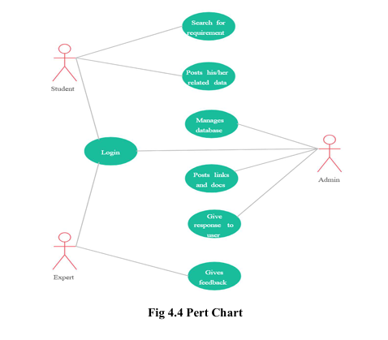

**CHAPTER 5**

**PROJECT SCREENSHOTS**

1. **Login Page**

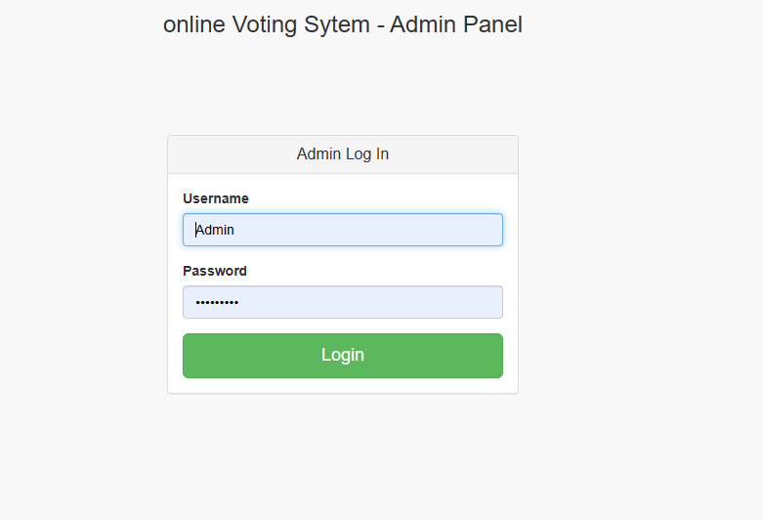

Figure 5.1 Login Page

**B. Sign page**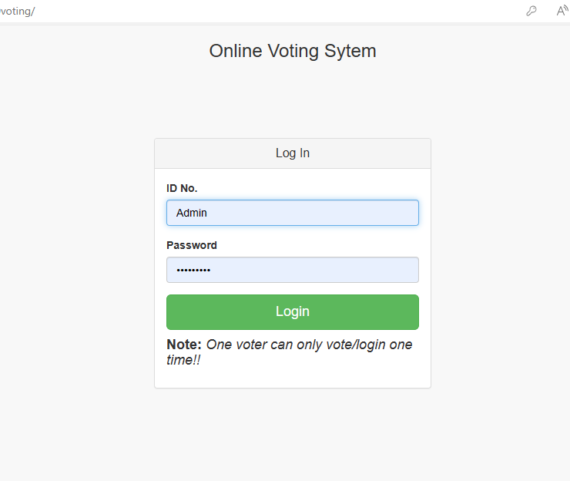

Figure 5.2: Sign up Page

**C. Dashboard**

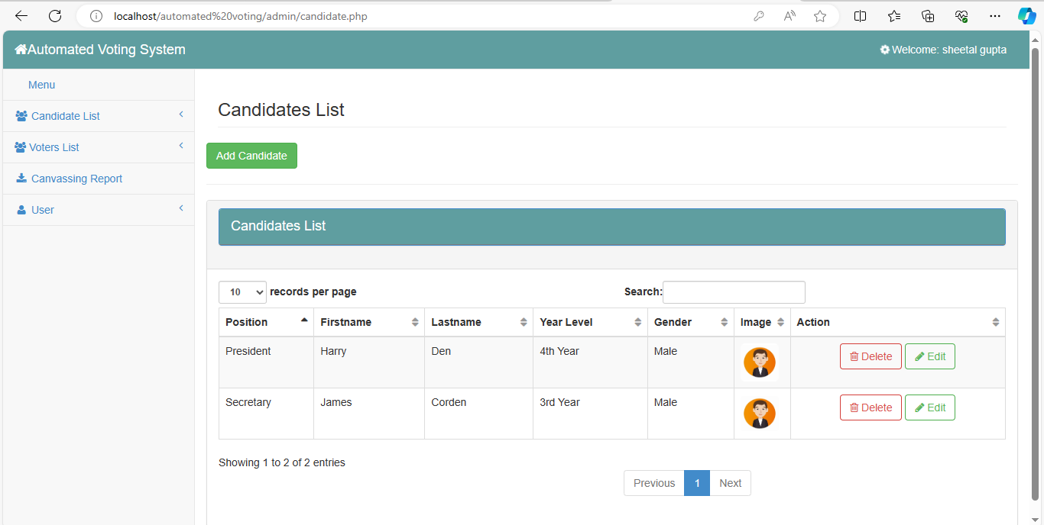

Figure 5.3: Dashboard

**D. Add Candidate**

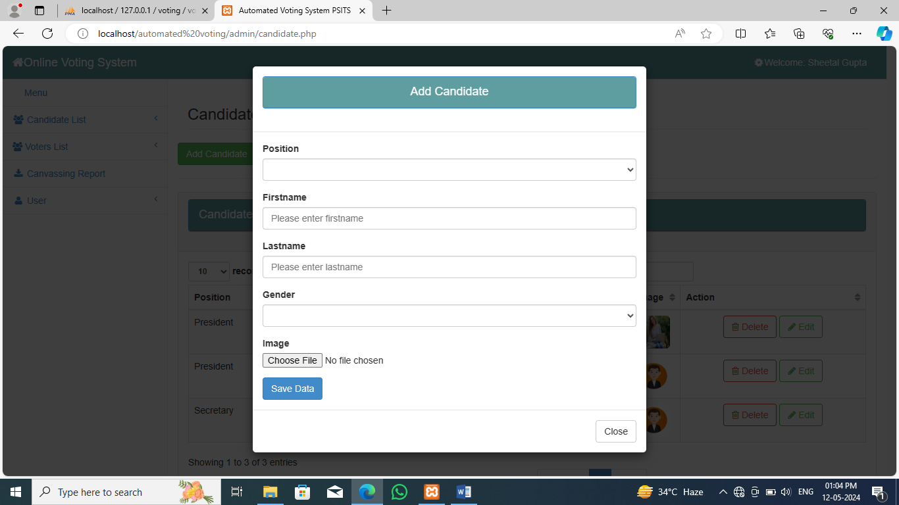

Figure 5.4: Candidate

**E. Add Voter**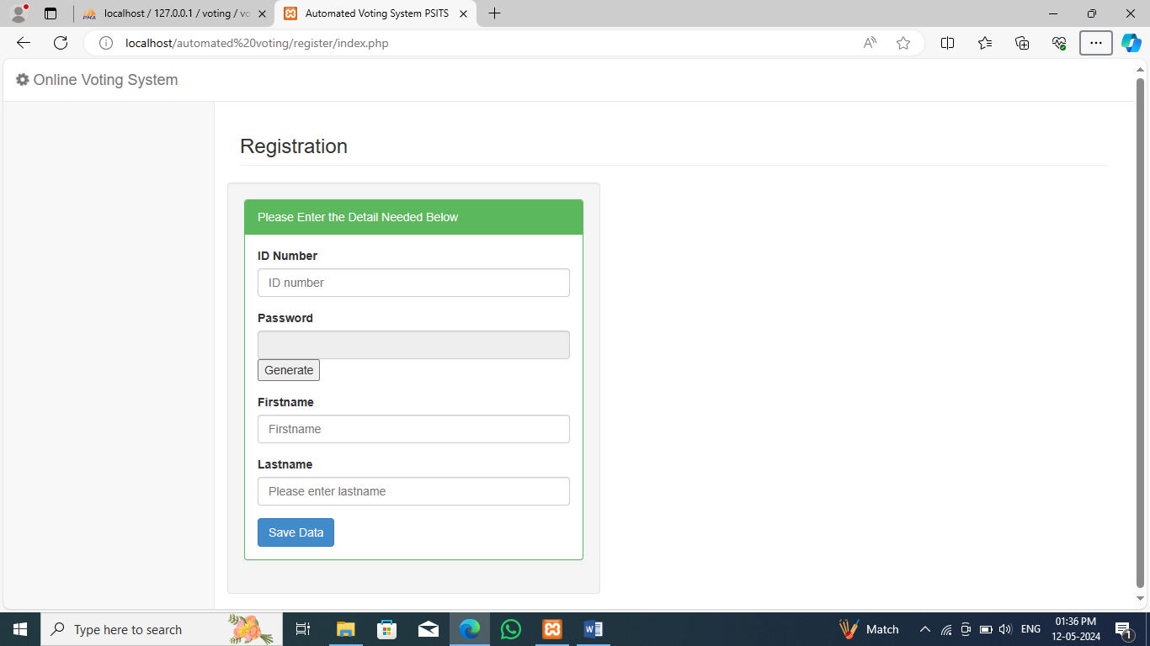

Figure 55: Registration Page

**CHAPTER 6**

**CHOICE OF TOOLS & TECHNOLOGY**

**6.1 PHP**

PHP (Hypertext Pre-processor) is a widely-used server-side scripting language that is designed for web development. It is embedded within HTML code and executed on the server, producing dynamic content that is then sent to the client's web browser.

PHP is renowned for its simplicity, versatility, and ease of integration with various databases, making it a cornerstone technology in modern web development. Modern PHP embraces Object-Oriented Programming principles, allowing developers to organize code in a more modular and reusable manner.

OOP in PHP involves the use of classes and objects, promoting better code organization, encapsulation, and the creation of scalable applications. PHP has a vibrant ecosystem of frameworks that facilitate rapid and efficient web development. Frameworks like Laravel, Symphony, and Code Igniter provide standardized architectures, pre-built modules, and tools that enhance developer productivity. These frameworks adhere to best practices, such as MVC (Model-View-Controller), promoting clean and maintainable code.

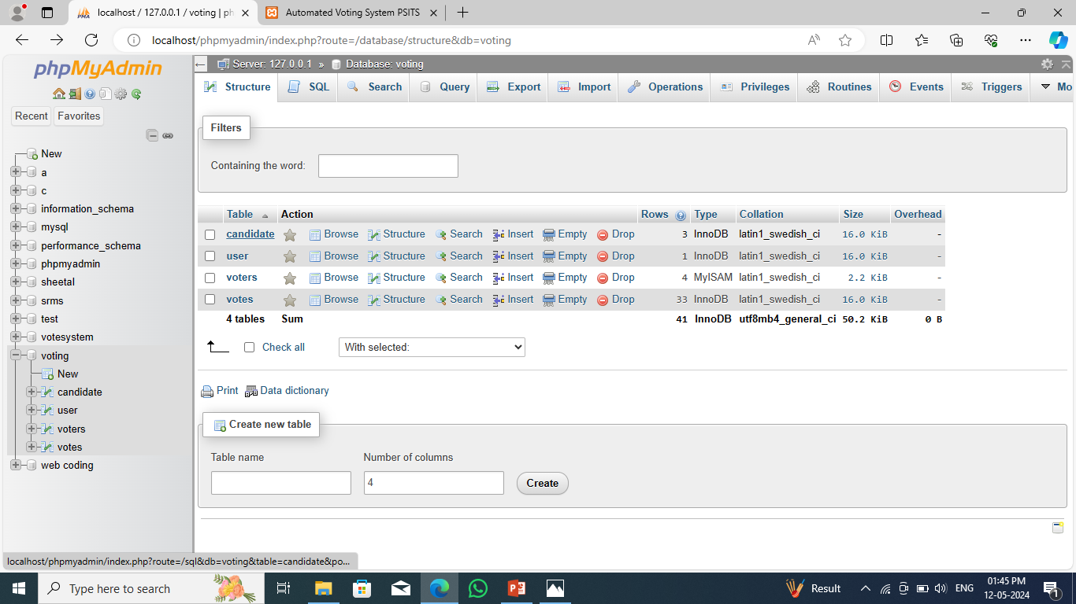

**Fig no: 6.1 Php**

**6.2 MySQL**

MySQL is a popular choice of database for use in web applications, and is a central component of the widely used LAMP open-source web application software stack (and other 'AMP' stacks). LAMP is an acronym for "Linux, Apache, MySQL, and Perl/PHP/Python." Free-software-open-source projects that require a full-featured database management system often use MySQL.

MySQL is a widely utilized relational database management system (RDBMS) that is a popular choice for web applications due to its robustness, reliability, and ease of use. It plays a crucial role as the database component in various open-source web application stacks, most notably the LAMP stack.

LAMP stands for Linux (the operating system), Apache (the web server), MySQL (the database management system), and Perl/PHP/Python (the programming languages). This stack provides a powerful, versatile foundation for developing and deploying dynamic web applications. MySQL is frequently selected for web-based projects ranging from content management systems (CMS) and e-commerce platforms to complex data-driven applications

Its role in the LAMP stack underscores its importance in the web development landscape, providing a reliable and efficient database solution for developers worldwide.

**6.3 Data Flow**

Diagram The data flow diagram shows the flow of data within any system.

It is an important tool for designing phase of software engineering. Larry Constantine first developed it. It represents graphical view of flow of data. It’s also known as BUBBLE CHART.

The purpose of DFD is major transformation that will become in system design symbols used in DFD: -

In the DFD, four symbols are used and they are as follows.

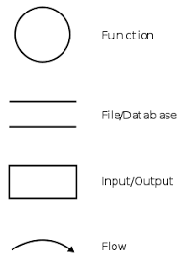

**6.4 Context Level Diagram**

This level shows the overall context of the system and its operating environment and shows the whole system as just one process. Canteen Management System is shown as one process in the context diagram; which is also known as zero level DFD, shown below. The context diagram plays important role in understanding the system and determining the boundaries. The main process can be broken into sub processes and system can be studied with more detail; this is where 1st level DFD comes into play.

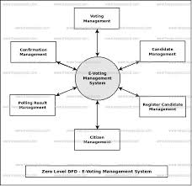

**Fig no: 6.4 0 level DFD**

The Level 0 DFD shows that the Administrator/User interacts with the Student Information System by providing student details and receiving final reports. The Student Information System processes the data, stores it in the MySQL database, and retrieves necessary information from the database to generate reports. This high-level diagram provides a clear overview of the system's functionality and how data flows between the user, system, and database.

**Level 1**

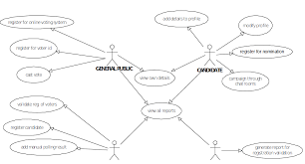

**Fig no: 6.4 1 level DFD**

**CHAPTER 7**

**TESTING**

Testing is a process of executing a program with the intent of finding bugs that makes the application fail to meet the expected behaviour. System Analysis and Design process including Requirement Analysis, Business Solution Options, Feasibility Study, and Architectural Design was discussed in previous chapter. Generally Software bugs will almost always exist in any software module. But it is not because of the carelessness or irresponsibility of programmer but because of the complexity.

Humans have only limited ability to manage complexity. This chapter discusses about the testing of the solution and implementation methodologies. Regardless of the development methodology, the ultimate goal of testing is to make sure that what is created does what it is supposed to do. Testing plays a critical role for assuring quality and reliability of the software. I have included testing as a part of development process. The test cases should be designed with maximum possibilities of finding the errors or bugs. Software Testing is the process of executing a program or system with the intent of finding errors. The scope of software testing often includes examination of code as well as execution of that code in various environments and conditions.

Software Testing is a method to check whether the actual software product matches expected requirements and to ensure that software product is Defect free. It involves execution of software/system components using manual or automated tools to evaluate one or more properties of interest. The purpose of software testing is to identify errors, gaps or missing requirements in contrast to actual requirements. Testing stage of The project can be explained as below and system was tested for all these stages. Various level of testing are as follows

**7.1 TESTING LEVELS**

**Unit testing**: Unit testing tests the functionality of individual units of source code. It is the smallest component of a testable software that works in isolation with other parts of the code. I have done unit testing for various individual components of the source code to uncover errors within the boundary of the application.

**Integration testing:** Integration testing focuses on the design and construction of the software. Here the individual components that are tested using unit tests are combined and tested as a group. Its primary purpose is to expose the defects associated with the interfacing of modules. It checks if the modules perform the desired functionality when integrated together

**System testing:** System testing is performed on a completely integrated system to see if it meets the requirements, System Testing is a type of software testing that is performed on a complete integrated system to evaluate the compliance of the system with the corresponding requirements. In system testing, integration testing passed components are taken as input.

**Regression testing:** Regression testing aims at verifying the functionality of the software that is previously tested and to which changes are made. It is to ensure the old software still works with new changes.

**Acceptance testing**: Acceptance testing is conducted to verify if the system compliance the business requirements. Software Testing is a method to check whether the actual software product matches expected requirements and to ensure that software product is Defect free. It involves execution of software/system components using manual or automated tools to evaluate one or more properties of interest. The purpose of software testing is to identify errors, gaps or missing requirements in contrast to actual requirements.

Adhering to the levels of testing, Unit testing is performed on individual components of the system ensuring the expected behaviour. Later, I have integrated various components together and performed Integration testing. Once the integration testing is done, I have

Performed System 30 testing and ensured the application works as per the requirements. Finally, acceptance testing is performed to check if the client accepts the system

**Performance Testing:** Performance testing is performed to determine how well the system can perform in terms of responsiveness under all kinds of load. The web application is tested to see if it can sustain huge amount of requests providing higher throughput under different loads. I have simulated multiple hits on various pages of the application to evaluate the overall performance.

**7.2 TEST CASE**

**7.2.1 FOR USER SIGNUP**

|  |  |
| --- | --- |
| **FIELD** | **DETAILS** |
| Id | 78955 |
| Password | ****** |

Table: Record entered successfully

**7.2.2 LOGIN CASE**

|  |  |
| --- | --- |
| **FIELD** | **DETAILS** |
| username | admin |
| Password | ****** |

Table: Logged in successfully

**CHAPTER 8**

**FUTURE SCOPE AND CONCLUSION**

The future of the Twitter clone holds immense potential for growth and innovation. Here are some key areas for future development:

**8.1ENHANCED USER EXPERIENCE:**

* Implementing advanced algorithms for personalized content delivery based on user preferences and behaviour.
* Integration of augmented reality (AR) and virtual reality (VR) elements to create a more immersive user experience.

**8.2ADVANCED CONTENT MODERATION:**

* Leveraging machine learning and artificial intelligence for more effective and nuanced content moderation, reducing the prevalence of harmful or inappropriate content.
* Incorporating block chain technology to ensure transparency and accountability in content moderation decisions.

**8.3 MONETIZATION STRATEGIES:**

* Introduction of innovative monetization features, such as exclusive content subscriptions, premium user accounts, and a decentralized tipping system.
* Exploring partnerships with businesses for targeted advertising and sponsored content.

**8.4 GLOBAL EXPANSION:**

* Focusing on expanding user bases in untapped markets and regions to create a truly global social media platform.
* Localization efforts to cater to diverse linguistic and cultural preferences.

**8.5 INTEROPERABILITY AND INTEGRATION:**

* Facilitating seamless integration with other popular social media platforms and communication tools.
* Exploring interoperability with emerging technologies, such as the integration of decentralized identity systems.

**CHAPTER 9**

**CONCLUSION**

In conclusion, a student management system is a valuable tool for educational institutions to efficiently manage various aspects of student information and academic processes. Through features such as student profiles, attendance tracking, grading systems, and communication tools, these systems streamline administrative tasks, improve communication between stakeholders, and provide valuable insights into student performance and progress. Some key benefits of student management systems include:

**7.1 ENHANCED ORGANIZATION**

* Centralizing student data and administrative tasks helps institutions stay organized and reduces the likelihood of errors or oversights.

**7.2 IMPROVED COMMUNICATION**

* Built-in communication tools allow for easier collaboration between students, teachers, administrators, and parents, facilitating timely updates and feedback.

**7.3 INCREASED EFFICIENCY**

* Automation of routine tasks such as attendance tracking, grading, and scheduling frees up time for educators to focus on teaching and student support.

**BIBLIOGRAPHY**

[1] Introduction To PHP Retrieved on 10/10/2023 from <https://www.tutorialspoint.com/php/index.html>

[2] <https://www.udemy.com/course/create-a-twitter-clone-with-php-mysql-and-js-from-scratch/>

[3] <https://www.geeksforgeeks.org/php-tutorial/>

[4] <https://www.javatpoint.com/php-tutorial>

[5] <https://www.javatpoint.com/javascript-tutorial>